Unit 6 -The Hydrosphere (**=tested items)
**How is Water Used?
- 70% in Irrigation
- 20% in Industries
- 10% in Cities and Residences

Ocean Currents --- Is the mass of ocean water that flows from one place to another
**How do Currents Influence Climate?
- Exchanges heat in the water with the atmosphere
- Type of current nearby influences weather for an areas
  - Warm currents bring warm temperatures
  - Cold currents bring cooler temperatures

**Current Movement
Warm Currents  - Move from the tropics to the poles  - Ex: Gulf Stream (east coast of the US) | Cold Currents  - Move from the poles to the equators  - Ex: Canary Current
**Why do Current Moves?
Primary Forces  - Solar heating, winds, gravity, Coriolis | Secondary Forces  - Influences where the current flows
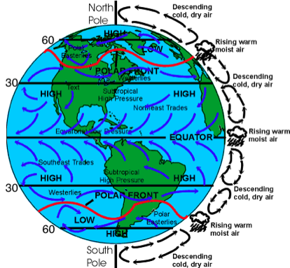

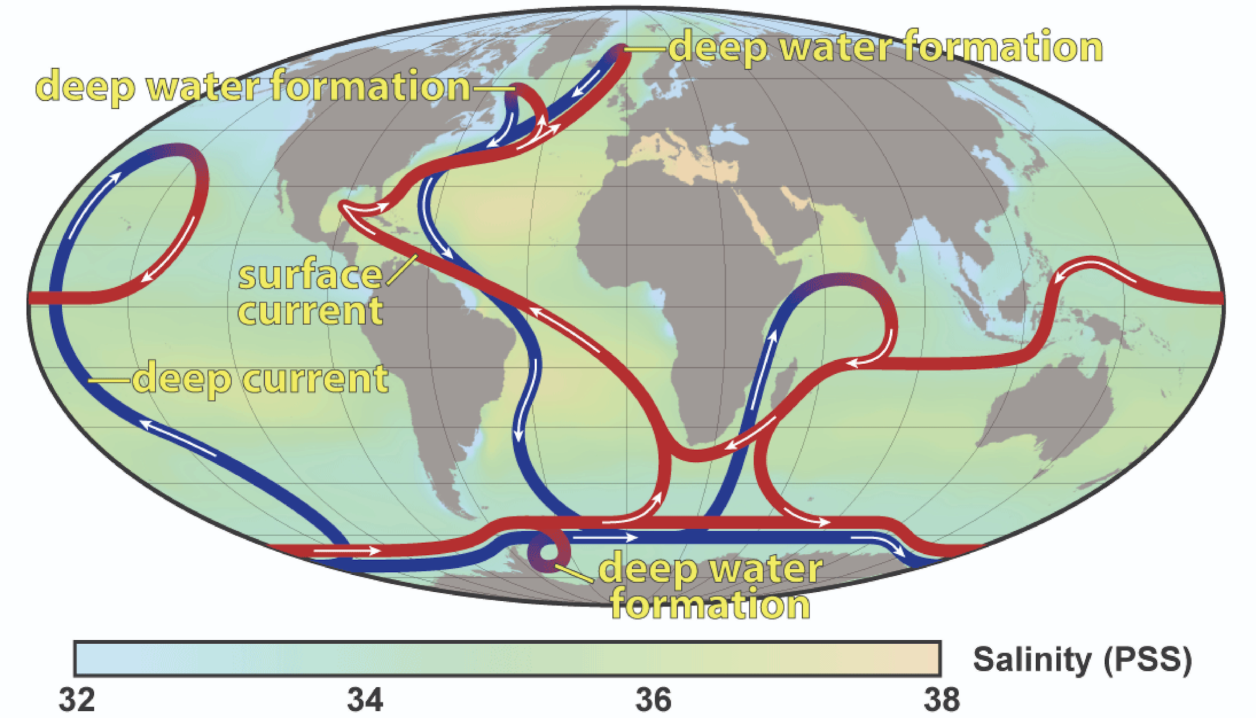

Freshwater Facts
- Primary use for freshwater in U.S. is for agriculture
- In our homes, we use the most freshwater to wash, clean and flush.
- The typical person in an industrialized nation uses 700-1000 gallons of freshwater per week
Distribution of Water On Earth
- 71% of Earth is water
  - 97% in the oceans
  - 3% is freshwater
    - 2% in ice and glaciers
    - 0.6% in underground water
    - 0.4% in rivers, streams, lake and atmosphere
**What is Groundwater?
- Water that is below the surface
- 50% of water used by the public is groundwater

**How does water become Groundwater?
- Permeability
  - How easily water can pass through connected pore spaces
- Porosity
  - Percentage of pore spaces in soil and rock
  - Clay has the smallest percentage (not permeable)

**Aquifers----Underground layer of water bearing permeable rock (gravel, sand or silt) from which ground water can be extracted using a well
**Wells
- A hole bored into the zone of saturation
- Pumping can cause the water table to be lowered
- Artesian Well----Groundwater rises on its own under pressure
- Cone of depression --- Occurs in an aquifer when a lot of groundwater is pumped from the well
**Problems with Groundwater
- Withdrawing water for agriculture
- Toxic metals contaminating the water (arsenic, cadmium, lead)
- Salt water intrusion
  - Salt water from the ocean enters the groundwater near coastal areas

**What is a Flood?
- When the stream or river overloads the capacity of its channel and overflows it banks
- Most floods are caused by rapid spring snow melting or storms that bring heavy rains over a large region

**How to control Floods?
- Artificial Levees
  - Concrete or Earthen mounds built on the banks of a river
  - Increases the amount of water it can hold
- Natural Levees
  - Parallels a stream and helps to contain its water, except during flood stage
- Flood-Control Dams
  - Stores floodwater and lets it out slowly
- Limit Development
  - Preserve floodplains instead of building on them

Human Activities Causing Flooding
- Removing vegetation
- Overgrazing
- Mining
- Building on floodplains
- Logging
- Forest fire
- Destruction of wetlands
- Urbanization

**The Water Cycle-----Water is constantly moving among the oceans, the atmosphere, the solid earth and biosphere
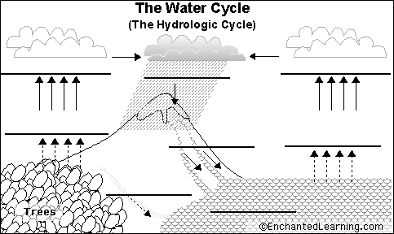
**Parts of the Water Cycle
- Evaporation: liquid water changes into water vapor
- Precipitation: liquid or solid water from the clouds
- Condensation: water vapor that turns into liquid making clouds
- Infiltration: liquid water moving through the ground
- Transpiration: water vapor released to the air by plants
- Runoff: when liquid hit the ground but not absorbed
**What does Water Balance Mean? ---- Precipitation equals evaporation

