LIMITING FACTORS

OBJECTIVES:
- To learn about various limiting factors that influence population dynamics
- To investigate which factors affect yellow perch in Lake Winnipeg

LIMITING FACTORS
All living things need food, water, shelter and space to survive. As long as organisms have all of these things available to them their population will continue to grow. However, populations cannot grow forever. Some form of environmental resistance will stop the population’s growth. The form of environmental resistance is called a limiting factor since it limits the population. However, limiting factors may also increase a population. We will look at many different limiting factors and classify them into density independent factors and density
dependent factors.

KEY TERMS THAT WILL HELP YOU IN YOUR READING
- Natural disasters: disasters caused by nature
- Density: organisms per unit area
- Toxic: poisonous
- Tail races: area of water located behind a dam
- Aquatic: taking place in or on the water
- Penetrate: to enter or force a way into
- Depletion: the use or consumption of a resource
- Turbid: degree of cloudiness of water
- Tributaries: a stream that flows into a larger stream or other body of water
- Invasive: moves in without right or permission, intrusive

YOUR TASK
- Read the notes on limiting factors; make sure you note the different factors
- Read the scenario about Lake Winnipeg and underline all the limiting factors that affect the survival of the yellow perch. Underline the terms you are unsure of and check for the definition in the key terms section above.
- Answer the analysis questions below, identifying the limiting factors.

WHAT ARE LIMITING FACTORS?
All living things need food, water, shelter and space to survive. As long as organisms have all of these things available to them their population will continue to grow. However, populations cannot grow forever. Some form of environmental resistance will stop the population’s growth. The form of environmental resistance is called a limiting factor since it limits the population. However, limiting factors may also increase a population. We will look at many different limiting factors and classify them into density independent factors and density dependent factors.
DENSITY INDEPENDENT FACTORS
Density independent factors can affect a population no matter what it’s density is. For example: natural disasters, temperature, sunlight, human activities, physical characteristics and behaviors of organisms affect any and all populations regardless of their densities.
Natural disasters such as droughts, floods, hurricanes and fires can be devastating to aquatic life. For example, a severe drought could lower the water levels of Lake Winnipeg and decrease its carrying capacity. Thus, the fish population would decrease.
Temperature influences the activity and growth of organisms. Temperature also determines which type of organisms can live in a lake. Usually, higher water temperature increases the activity in a lake. However, all aquatic species have a preferred temperature range. If temperatures vary too much out of this range the species will either die or move to a different location. Temperature also influences the chemical properties of water. The rate of chemical reactions in the water increases as temperature increases. For example, warm water holds less oxygen than cool water, so even though there is more activity in warm water there may not be enough oxygen for the activity to continue for long periods of time.
Sunlight can only penetrate to a depth of 30 meters in water. Thus most photosynthesis in aquatic environments occurs near the surface. This means that most plants cannot grow if they are at the bottom of a deep lake.
Human activities can also affect population dynamics. For instance, lake sturgeon spawn in fast water and sometimes use the “tailraces” of hydroelectric dams. However, the water level in this location often drops suddenly and the eggs die because they become exposed.
Physical characteristics of organisms can affect their population. Many organisms have adapted and evolved in order to increase their chance of survival. For example, some species of fish have colored markings to warn predators that they may be toxic. Or, some species use camouflage colors to help them hide and avoid being eaten.
Behaviors of organisms can also affect their population. For example, some species migrate to find new food sources or to mate. Some organisms create societies or feeding territories. For instance, white bass live in schools and work together to drive emerald shiners to the surface for feeding. Some species may have mating or courtship behaviors that affect their population.

DENSITY DEPENDENT FACTORS
Density dependent factors can only affect a population when it reaches a certain density. For example, competition, predation, disease, parasitism, crowding, and stress are all factors that only affect populations with high densities.
Competition can occur between many organisms that live in the same habitat. Resources are limited in a habitat so organisms must compete for food, water, space, and shelter. For example, both northern pike and walleye prey on yellow perch and so they compete for the same food source. However, this competition is only apparent when the populations of northern pike and walleye have high densities OR the population of yellow perch has a low density.
Predation occurs when the population density of predators is high. The predators will consume their prey and increase their own population. However, the population of the prey will decrease. On the other hand, the lack of predation (when the population density of predators is low) will cause problems for the prey’s population. When there are few predators, the prey’s population increases very quickly and this can lead to the depletion of resources and increase disease.
Disease in a population increases with the density of that population. High densities makes it easier for parasites to find hosts and spread the disease.
Parasitism is a relationship in which one species benefits at the expense of the other. A parasite is an organism that lives in or on another organism (called a host) to get nourishment. While the parasite benefits from this relationship the host is harmed or killed.
Space Availibity is the amount of space available for an organism to live. Organisms require a certain amount of space in order to survive. Over-crowding can cause depletion of resources, disease and stress on the organisms.
Stress usually has a negative effect on populations. Stress can make organisms weak and more prone to disease.

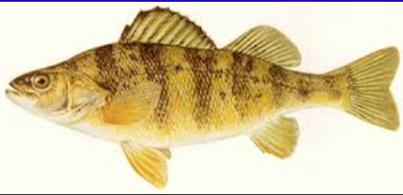
SCENARIO: YELLOW PERCH IN LAKE WINNIPEG
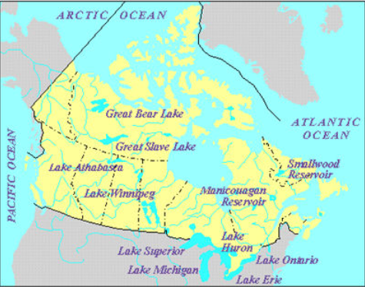
Located 217 m above sea level, Lake Winnipeg is a shallow lake composed of two basins: a wide north basin and a narrow south basin. On average, Lake Winnipeg is only 12 meters deep and receives 517 mm of precipitation annually.
Lake Winnipeg provides a habitat for over 50 different species of fish including yellow perch, chestnut lampreys and rainbow smelt. Yellow perch prefer water that has little current. They can tolerate moderate tubidity. Also, they prefer a temperature range of 18 to 20 degrees Celsius. If the temperature of the water varies too much above this range, yellow perch will either move to a new location or die.
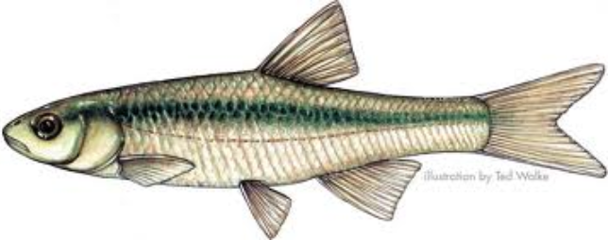
Yellow perch spawn in May or early June when water temperatures are above 6 degrees Celsius. First, they migrate to tributaries and then several males attend a female while she releases her eggs. Yellow perch can grow to 302 mm in length. Their life span is approximately 9 years. If there is a lack of resources or too many of them (over-population), yellow perch adapt by stunting. This means that instead of starving, they simply do not grow as large as normal. Thus, they are able to live off less food.
Yellow perch feed in midwater or on the bottom of Lake Winnipeg. They eat a wide variety of invertebrates, and fish such as emerald shiners (the fish pictured at right). The eyes of yellow perch allow them to see almost 360 degrees around them. Thus, they are better able to spot their prey and evade predators.
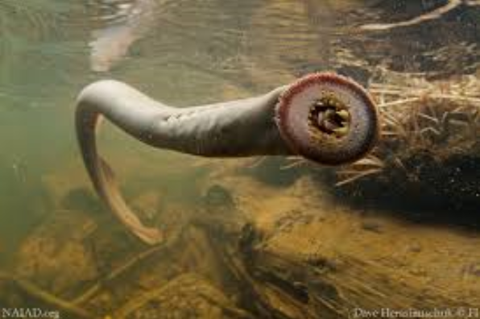
In Lake Winnipeg, yellow perch are eaten by northern pike and walleye. They are also caught for food by commercial fishers and anglers. Chestnut lampreys are also found in Lake Winnipeg. Lampreys (pictured at left) are parasitic fish that attach to other species of fish (such as yellow perch) to feed on their blood and tissues.
Recently, rainbow smelt have been introduced into Lake Winnipeg. Rainbow smelt are a very invasive and competitive species. They have been thought to have caused a decrease in the emerald shiner population.
Lake Winnipeg provides a home for many species of fish. However, a severe drought could disrupt this ecosystem greatly. Lake Winnipeg’s water level would drop, the temperature could change and it could become more turbid. Thus, the carrying capacity of the lake would change. But, in its current condition, Lake Winnipeg is an excellent habitat for many species of fish.
ANALYSIS Name:
- From the previous article “Yellow Perch in Lake Winnipeg”, identify and describe as many limiting factors as possible.

Each of the statements below involves a situation that will affect the growth of a population. Identify the limiting factor at work and explain why you chose the limiting factor
- Rainbow smelt and yellow perch attempt to occupy the same area. The more aggressive smelt survive; the perch do not. Limiting factor?_________________________________________________________
Explain__________________________________________________________________________________________________________________________________________________________________
- A severe flood brings a lot of sediment and silt into Lake Winnipeg. The turbidity of the lake increases greatly. Limiting factor?________________________________________________________________
Explain__________________________________________________________________________________________________________________________________________________________________
- A drought decreases the water level in Lake Winnipeg. The carrying capacity of the lake decreases.
Limiting factor?_______________________________________________________________________
Explain__________________________________________________________________________________________________________________________________________________________________
- Due to the introduction of rainbow smelt, Lake Winnipeg becomes crowded and some fish species do not survive. Limiting factor?_____________________________________________________________
Explain__________________________________________________________________________________________________________________________________________________________________
- Since northern pike prey on yellow perch, an increase in the perch population causes an increase in the pike population. Limiting factor?_________________________________________________________
Explain__________________________________________________________________________________________________________________________________________________________________
- Many fish die due to an increase in water temperature. Limiting factor?__________________________
Explain__________________________________________________________________________________________________________________________________________________________________
- Due to over-fishing, the number of walleye in Lake Winnipeg decreases.
Limiting factor?_______________________________________________________________________
Explain__________________________________________________________________________________________________________________________________________________________________
- A population is growing quickly when parasites cause disease to spread quickly.
Limiting factor?_______________________________________________________________________
Explain__________________________________________________________________________________________________________________________________________________________________
- Since lake sturgeon migrate long distances to spawn, many do not survive the trip.
Limiting factor?_______________________________________________________________________
Explain__________________________________________________________________________________________________________________________________________________________________

Design your own scenario that describes a limiting factor. You may use a system other than the Lake to create your scenario.

ANALYSIS - Honors Name:
- From the previous article “Yellow Perch in Lake Winnipeg”, identify and describe as many limiting factors as possible.

Each of the statements below involves a situation that will affect the growth of a population. Identify the limiting factor at work and explain why you chose the limiting factor
- Rainbow smelt and yellow perch attempt to occupy the same area. The more aggressive smelt survive; the perch do not. Limiting factor?_________________________________________________________
Explain__________________________________________________________________________________________________________________________________________________________________
Density dependent or density independent?
- A severe flood brings a lot of sediment and silt into Lake Winnipeg. The turbidity of the lake increases greatly. Limiting factor?________________________________________________________________
Explain__________________________________________________________________________________________________________________________________________________________________
Density dependent or density independent?

- A drought decreases the water level in Lake Winnipeg. The carrying capacity of the lake decreases.
Limiting factor?_______________________________________________________________________
Explain__________________________________________________________________________________________________________________________________________________________________
Density dependent or density independent?
- Due to the introduction of rainbow smelt, Lake Winnipeg becomes crowded and some fish species do not survive. Limiting factor?_____________________________________________________________
Explain__________________________________________________________________________________________________________________________________________________________________ Density dependent or density independent?
- Since northern pike prey on yellow perch, an increase in the perch population causes an increase in the pike population. Limiting factor?_________________________________________________________
Explain__________________________________________________________________________________________________________________________________________________________________ Density dependent or density independent?
- Many fish die due to an increase in water temperature. Limiting factor?__________________________
Explain__________________________________________________________________________________________________________________________________________________________________ Density dependent or density independent?
- Due to over-fishing, the number of walleye in Lake Winnipeg decreases.
Limiting factor?_______________________________________________________________________
Explain__________________________________________________________________________________________________________________________________________________________________ Density dependent or density independent?
- A population is growing quickly when parasites cause disease to spread quickly.
Limiting factor?_______________________________________________________________________
Explain__________________________________________________________________________________________________________________________________________________________________ Density dependent or density independent?
- Since lake sturgeon migrate long distances to spawn, many do not survive the trip.
Limiting factor?_______________________________________________________________________
Explain__________________________________________________________________________________________________________________________________________________________________ Density dependent or density independent?
Design your own scenario that describes a limiting factor. You may use a system other than the Lake to create your scenario.

