Vocabulary Word | Information | Picture
Rotation | Causes Day & Night  Takes 24 hours  Earth’s motion on axis | 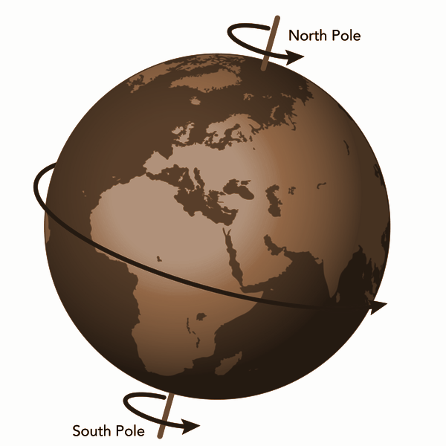
Revolution | Causes Seasons  Equation:  Tilt + Distance + Revolution + Rotation | 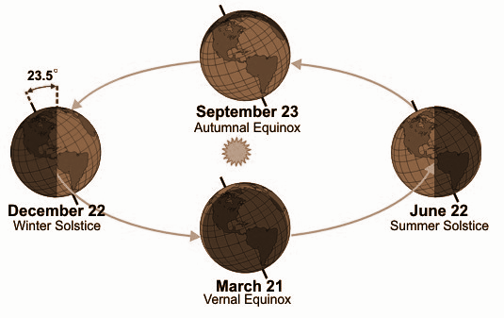
Elliptical | Shape of a planet’s revolution | 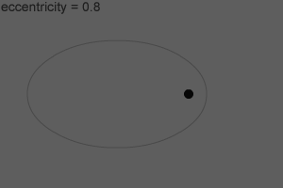
Weather | Day-to-Day  Current Conditions  Not based on location
Climate | Based on location and a collection of data over years | 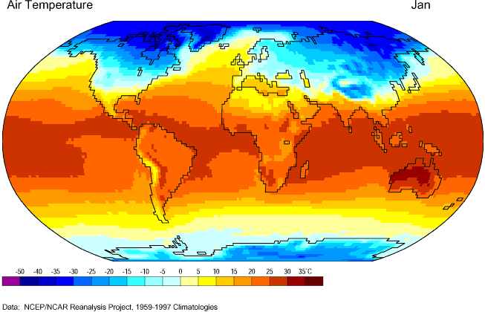
Ozone | A layer over Earth  Filters UV rays  Located in the stratosphere  Allows us to live on Earth | 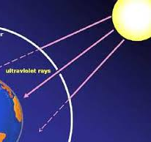
Land Temperatures | Retains heat longer  Cools down quicker
Water Temperatures | Takes longer to heat up
Troposphere | Location of weather | Right above Earth
Stratosphere | Location of ozone | Right above the Troposphere
Thermosphere | Hottest Layer  Ionosphere and Exosphere | Above Mesosphere
Atmosphere | 78% Nitrogen  Contains 4 layers | 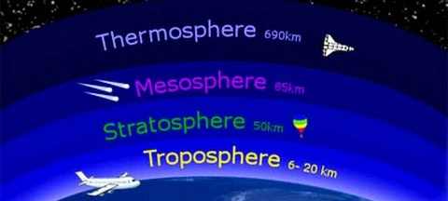
Solar Radiation | How the sun heats the Earth | 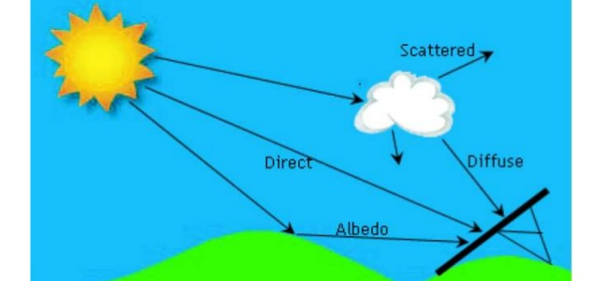
Relative Humidity | Amount of water vapor in the air in relation to the amount that location can hold based on air temperature | Cold air = smaller volume capacity  Warm air = larger volume capacity
Dew Point | When the amount of water reaches the temperature required to cool down the air | 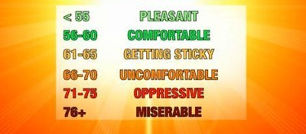
Isotherm | Mapping based on the same temperature | 